CSA1413
COMPILER DESIGN
Name: M Praneeth
Reg No: 192324184
Line Numbering

Aim:
To write a LEX program to read an input file, add line numbers to every line, and display the numbered content on the standard output.

Algorithm:
- Start the program.
- Include the required header file.
- Initialize the line number to 1.
- Open the input file in read mode and check for errors.
- Read the file line by line using LEX.
- Print the line number followed by the corresponding line content.
- Increment the line number after processing each line.
- Close the file and stop the program.

Pseudocode:
BEGIN
Include stdio.h
Initialize line_number = 1
Open the input file
IF file opening fails THEN
Print error message
EXIT
END IF
Assign file pointer to yyin
CALL yylex()
Close the input file
END
LEX RULE:
FOR each line in the file DO
Print line_number and line content
Increment line_number
END FOR

Code:
%{
#include <stdio.h>
int line_number = 1;
%}
%%
.*\n {
printf("%d: %s", line_number++, yytext);
}
.+ {
printf("%d: %s\n", line_number++, yytext);
}
%%
int main(int argc, char *argv[])
{
if (argc != 2)
{
printf("Usage: %s input.txt\n", argv[0]);
return 1;
}
yyin = fopen(argv[1], "r");
if (yyin == NULL)
{
printf("Cannot open input file!\n");
return 1;
}
yylex();
fclose(yyin);
return 0;
}
int yywrap(void)
{
return 1;
}

Input:
Compiler Design
lexical Analyzer
Syntax Analyzer

Output:
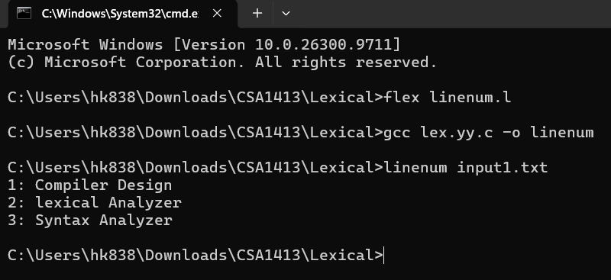

Result:
Thus, the LEX program to read an input file, add line numbers to every line, and display the numbered content on standard output was executed successfully.

